**Name: Zain ul abideen**

**Reg no:200901069**

Question no 1:

string=input("Enter a string")

string2=''

stack1=[]

for i in string:

sta("The entered string is not a palendrom")ck1.append(i)

while len(stack1)!=0:

string2=string2+stack1.pop()

if(string2==string):

print("The entered string is palendrom")

else:

print

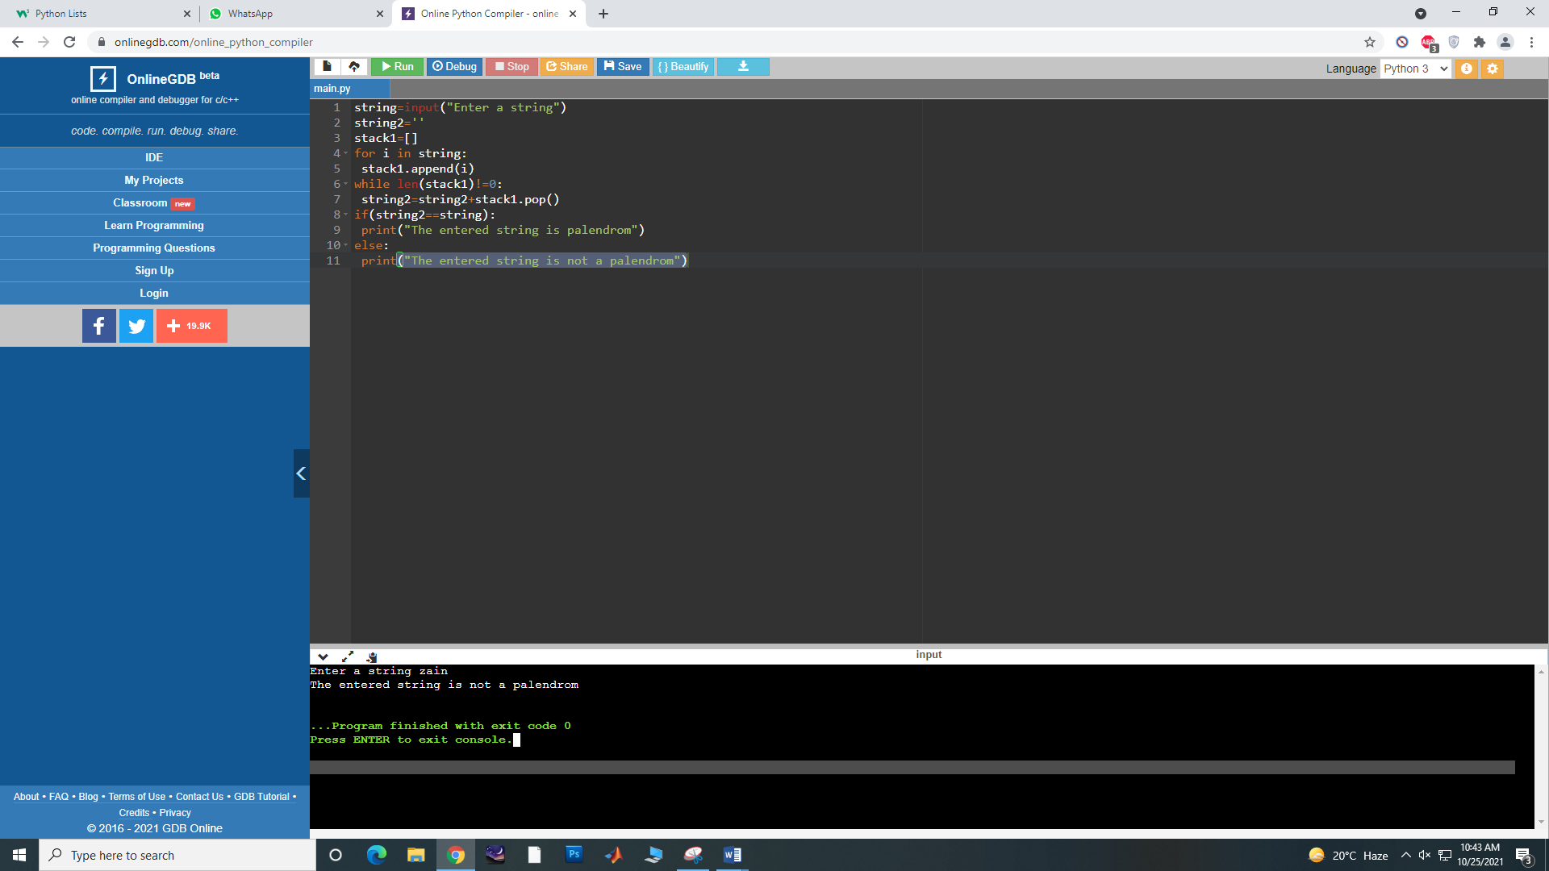

Question no 2:

expression=input("Enter an expression")

stack1=[]

var1=0

for i in expression:

if(i=='[' or i=='(' or i=='{'):

stack1.append(i)

if(i==']' or i==')' or i=='}'):

if(len(stack1)==0):

print("Unbalanced")

var1=var1+1;

else:

print(stack1.pop())

if ((len(stack1)==0) and var1==0):

print("Expression balanced")

else:

print("Expression unbalanced")

